

Ysgrifennu

Pum munud Nadolig

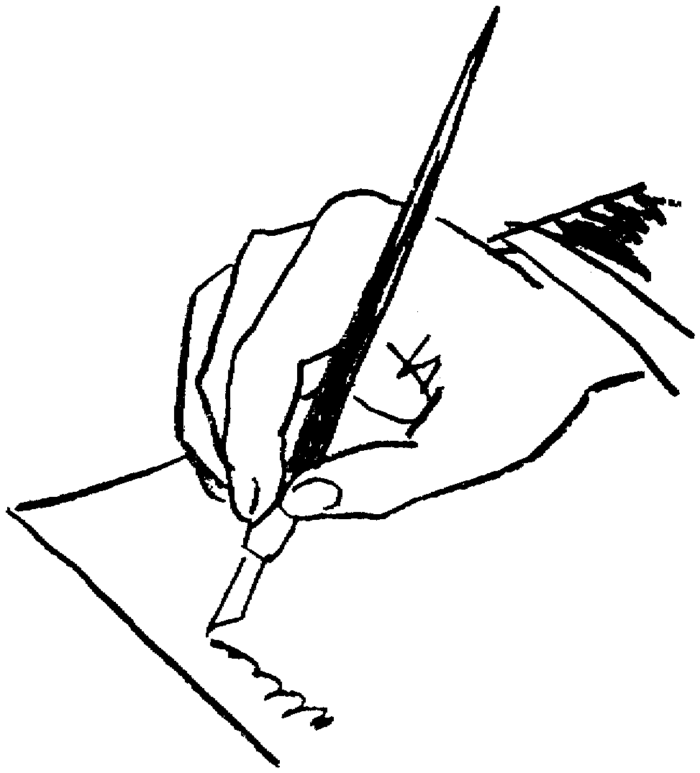

1. Yr anrheg orau erioed
..........................................................................................................................................................................................................................................................................................................................................................................................................................................................................................................................................................................................................................................................................................................................................................................................................................................................................................................................................................................................................................................................................................................................................................................................................................................................................................................................
2. Ysgrifennwch gerdd i ganmol bwyd Nadolig
......................................................................................................................................................................................................................................................................................................................................................................................................................................................................................................................................................................................................................................................................................................................................................................................................................................................................................................................................................................................................................................................................................................................

3. Sgwrs yn diolch am anrheg Nadolig. Rhaid defnyddio’r geiriau Dyna’r union beth...
..........................................................................................................................................................................................................................................................................................................................................................................................................................................................................................................................................................................................................................................................................................................................................................................................................................................................................................................................................................................................................................................................................................................................................................................................................................................................................................................................
4. Llythyr at Siôn Corn gan y Prif Weinidog
........................................................................................................................................................................................................................................................................................................................................................................................................................................................................................................................................................................................................................................................................................................................................................................................................................................................................................................................................................................................................................................................................................................................................................................................................................

5. Edrych ar y Nadolig o safbwynt un o geirw Siôn Corn.

..........................................................................................................................................................................................................................................................................................................................................................................................................................................................................................................................................................................................................................................................................................................................................................................................................................................................................................................................................................................................................................................................................................................................................................................................................................................................................................................................
6. Taset ti’n rhoi yr un anrheg i bob plentyn yn y byd, beth fasai fo?
......................................................................................................................................................................................................................................................................................................................................................................................................................................................................................................................................................................................................................................................................................................................................................................................................................................................................................................................................................................................................................................................................................................................

7. Gorffen y frawddeg mewn 10 ffordd wahanol:

Y Nadolig yma dw i’n gobeithio...

1. | ........................................................................................
2. | ........................................................................................
3. | ........................................................................................
4. | ........................................................................................
5. | ........................................................................................
6. | ........................................................................................
7. | ........................................................................................
8. | ........................................................................................
9. | ........................................................................................
10. | ........................................................................................

6. Taset ti’n rhoi yr un anrheg i bob plentyn yn y byd, beth fasai fo?
......................................................................................................................................................................................................................................................................................................................................................................................................................................................................................................................................................................................................................................................................................................................................................................................................................................................................................................................................................................................................................................................................................................................

