ar | yn
dan | wrth
sanau | tanwisg  budr
dillad | y llawr
croen | sgidiau

in | on
by | under
dirty  underwear | socks
the floor | clothes
shoes | skin

pysgod | ceffyl  wedi marw
teganau | tacluso
cwpwrdd | wardrob
y ddesg | y gegin
y llofft | y drôr

a dead  horse | fish
to tidy up | toys
wardrobe | cupboard
kitchen | the desk
the drawer | the bedroom

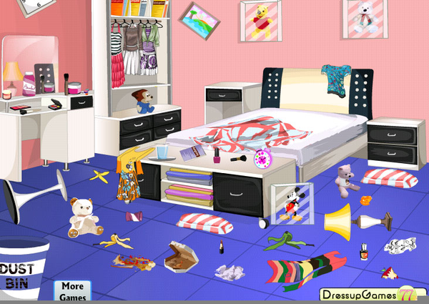
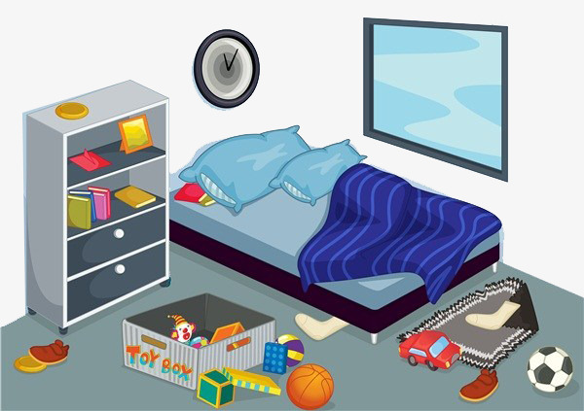
ei...o
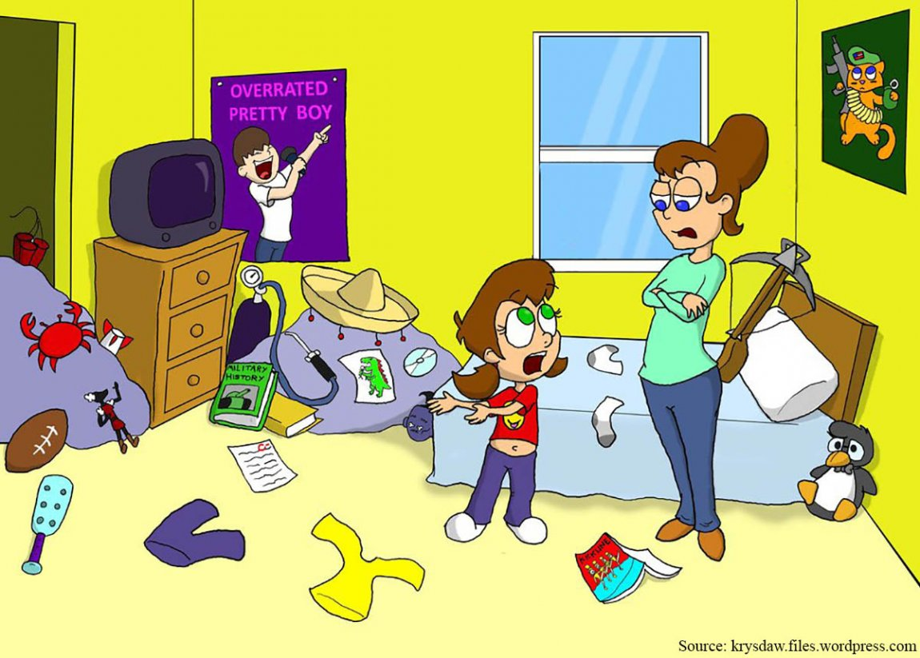
ei...hi

