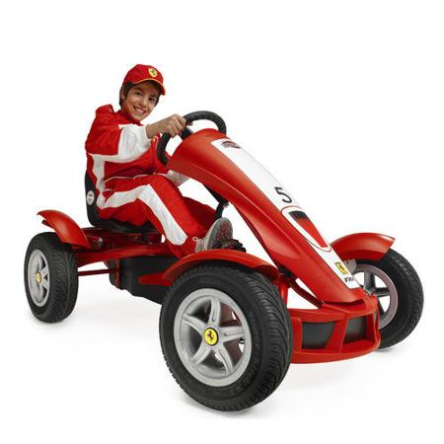
Tegan Ferrari Go-Kart
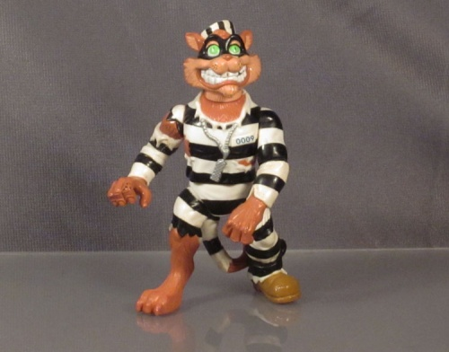
TMNT Scratch the Cat –
Teenage Mutant Ninja Turtles
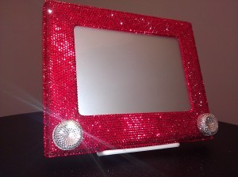
Etch-a-Sketch Swarovski
$989.99
$1,000

$1,500

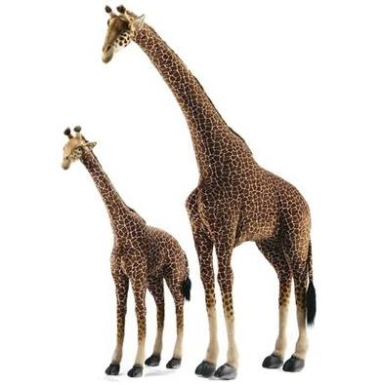
Jiraff maint dringo
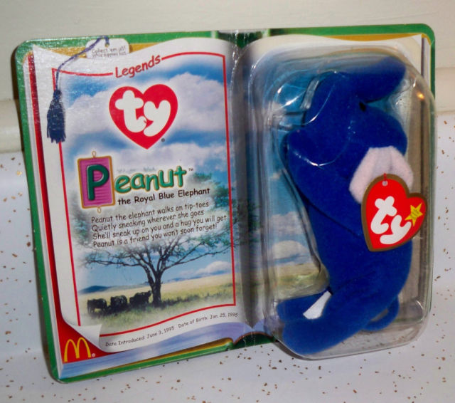
Eliffant ‘Beanie Baby’

Barbie efo deiamwntau
$1,680

$3,000

$302,000
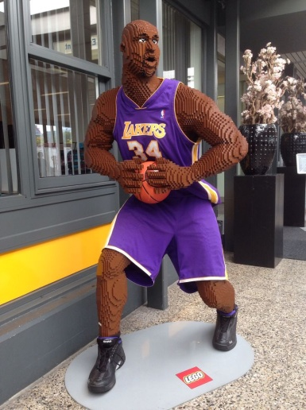
chwaraewr Lego maint person
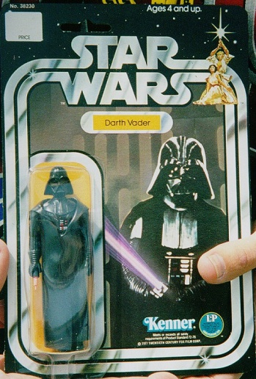
Darth Vader efo ‘light saber’
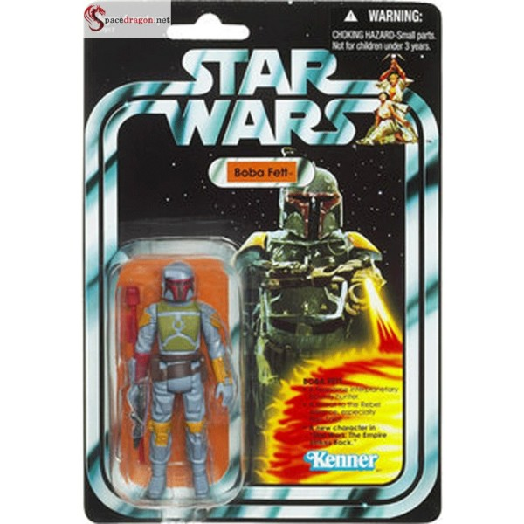
ffigwr Star Wars efo roced
$15,000
$6,000
$5,000
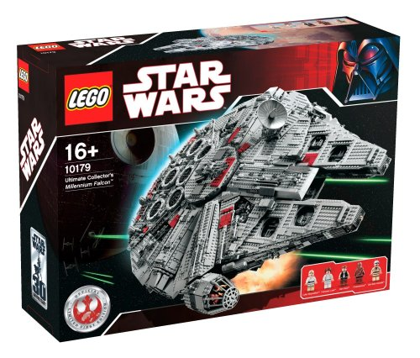
Millenium Falcolm Lego
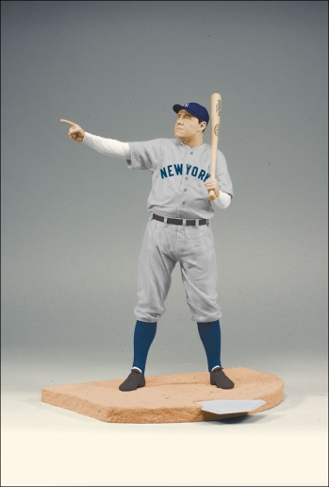
Ffigwr ‘Babe Ruth’
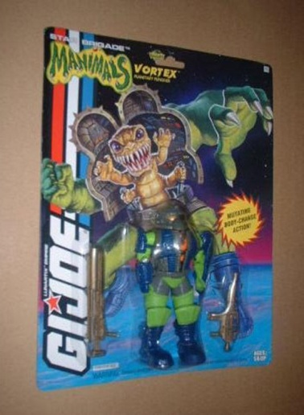
‘Manimal’ G.I. Joe
$4,677
$13,600
$20,000
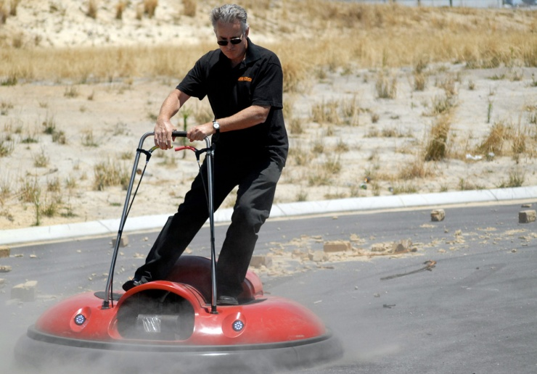
Sgwter dŵr
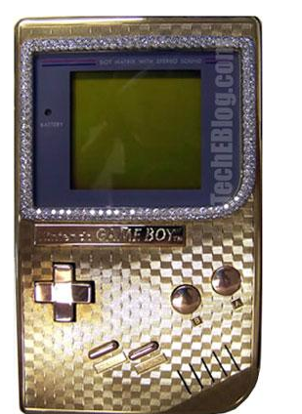
‘Game Boy’ aur
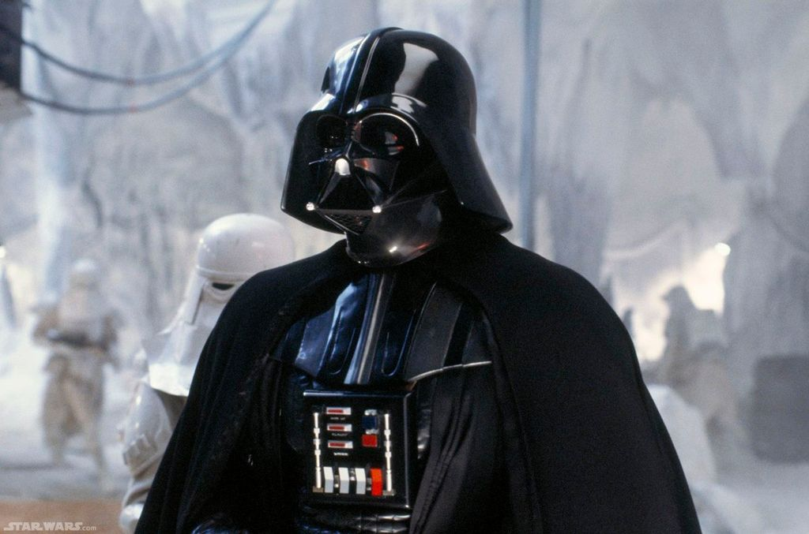
Helmed Darth Vader
$15,000
$25,000
$115,000
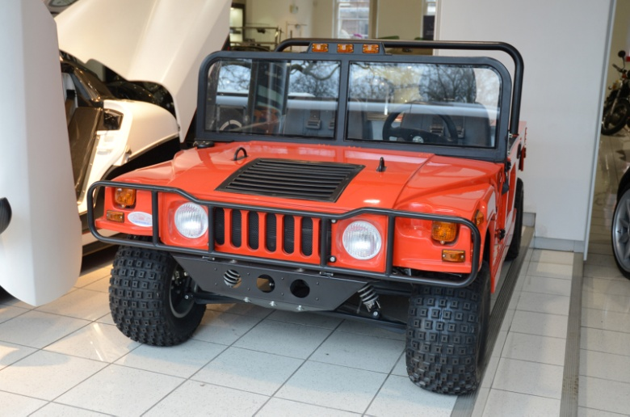
Car cefn gwlad maint plentyn
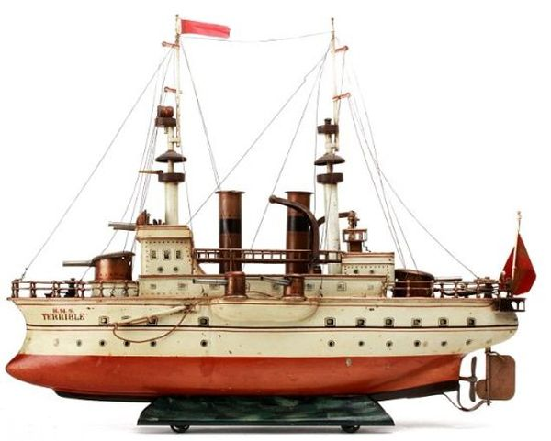
Llong tegan HMS Terrible
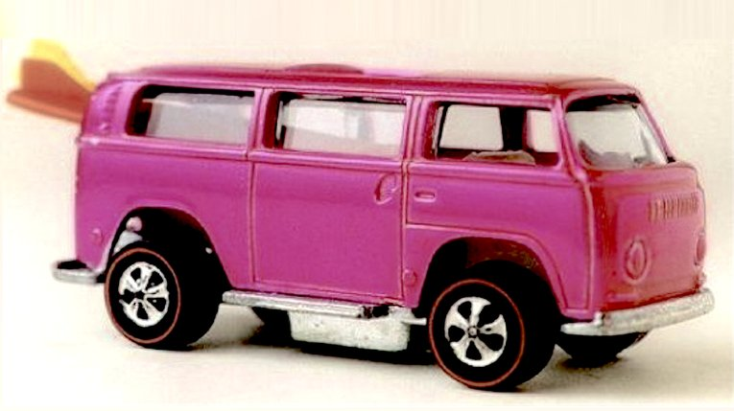
Volkswagen ‘Hot Wheels’
$30,000
$122,600
$72,000
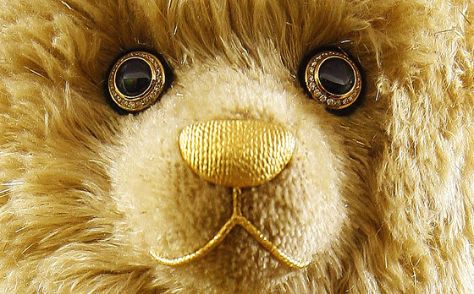
Tedi bêr Steiff efo tlysau
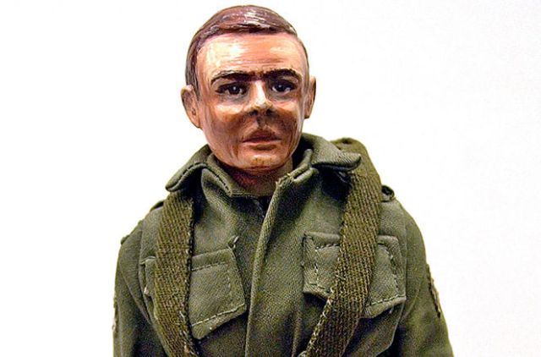
tegan prototeip GI Joe
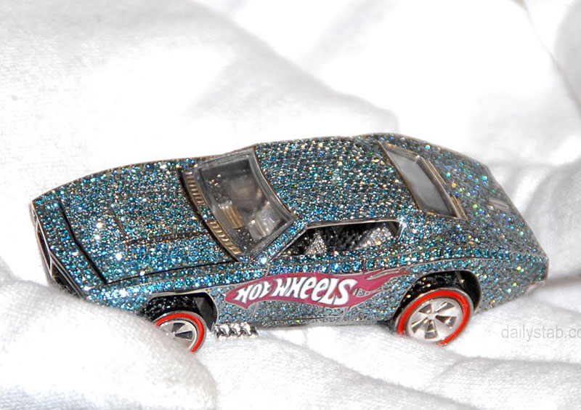
Hot Wheels efo deiamwntau

$193,000
$200,000
$140,000
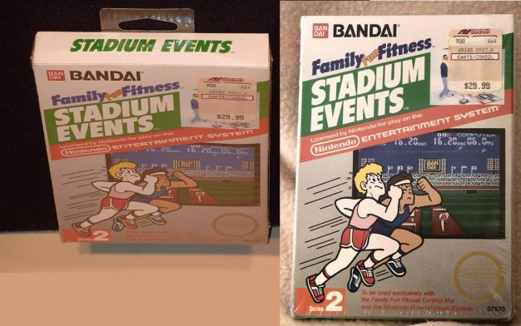
Nintendo Stadium Events
$22,800

