

Ysgrifennu

Pum

munud
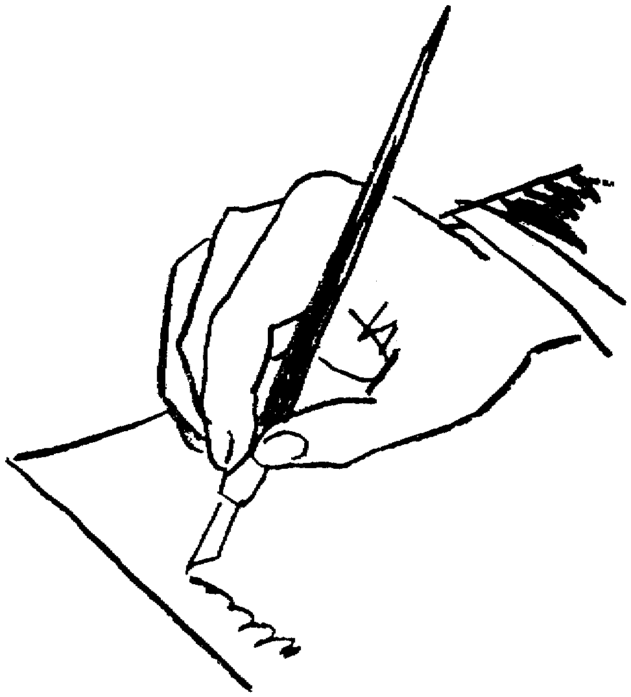

1. Enwch y coed oedd yn tyfu o gwmpas eich cartref pan oeddech chi’n ifanc.
....................................................................................................................................................................................................................................................................................................................................................................................................................................................................................................................................................................................................................................................................................................................................................................................................................................................................................................................................................................................................................................................................................................................................................................................................................................................................................................................................................
2. Ysgrifennwch gerdd i ganmol brechdanau
................................................................................................................................................................................................................................................................................................................................................................................................................................................................................................................................................................................................................................................................................................................................................................................................................................................................................................................................................................................................................................................................................................................................................................................................................................................
3. Mae grawnfwyd newydd wedi dod allan. Chi sy’n gyfrifol am ysgrifennu’r disgrifiad fydd yn gwneud i bawb eisiau ei brynu.
....................................................................................................................................................................................................................................................................................................................................................................................................................................................................................................................................................................................................................................................................................................................................................................................................................................................................................................................................................................................................................................................................................................................................................................................................................................................................................................................................................
4. Ysgrifennwch restr o dasgau y mae angen i’r Prif Weinidog eu gwneud heddiw.
................................................................................................................................................................................................................................................................................................................................................................................................................................................................................................................................................................................................................................................................................................................................................................................................................................................................................................................................................................................................................................................................................................................................................................................................................................................
5. Eich hoff degan pan oeddech chi’n blentyn.

....................................................................................................................................................................................................................................................................................................................................................................................................................................................................................................................................................................................................................................................................................................................................................................................................................................................................................................................................................................................................................................................................................................................................................................................................................................................................................................................................................
6. Disgrifiwch eich hoff ffrwyth heb ei enwi.
................................................................................................................................................................................................................................................................................................................................................................................................................................................................................................................................................................................................................................................................................................................................................................................................................................................................................................................................................................................................................................................................................................................................................................................................................................................

7. Atgof sy’n codi cywilydd arnoch chi.

....................................................................................................................................................................................................................................................................................................................................................................................................................................................................................................................................................................................................................................................................................................................................................................................................................................................................................................................................................................................................................................................................................................................................................................................................................................................................................................................................................
8. Disgrifiwch y tro cyntaf i chi yfed alcohol.

................................................................................................................................................................................................................................................................................................................................................................................................................................................................................................................................................................................................................................................................................................................................................................................................................................................................................................................................................................................................................................................................................................................................................................................................................................................
9. Eich hoff guddfan.
....................................................................................................................................................................................................................................................................................................................................................................................................................................................................................................................................................................................................................................................................................................................................................................................................................................................................................................................................................................................................................................................................................................................................................................................................................................................................................................................................................
10. Y peth hynaf sydd gennych chi.
....................................................................................................................................................................................................................................................................................................................................................................................................................................................................................................................................................................................................................................................................................................................................................................................................................................................................................................................................................................................................................................................................................................................................................................................................................................................................................................................................................

11. Y tro diwethaf i chi dwyllo neu ddweud celwydd.

....................................................................................................................................................................................................................................................................................................................................................................................................................................................................................................................................................................................................................................................................................................................................................................................................................................................................................................................................................................................................................................................................................................................................................................................................................................................................................................................................................
12. Pum peth fasech chi wedi hoffi gofyn i’ch Nain neu Taid.
....................................................................................................................................................................................................................................................................................................................................................................................................................................................................................................................................................................................................................................................................................................................................................................................................................................................................................................................................................................................................................................................................................................................................................................................................................................................................................................................................................
13. Mae gan bawb rhyw ddawn arbennig. Beth ydi’ch talent chi?

....................................................................................................................................................................................................................................................................................................................................................................................................................................................................................................................................................................................................................................................................................................................................................................................................................................................................................................................................................................................................................................................................................................................................................................................................................................................................................................................................................
14. Cyfarwyddiadau ar sut i dynnu sylw atoch chi’ch hun.
....................................................................................................................................................................................................................................................................................................................................................................................................................................................................................................................................................................................................................................................................................................................................................................................................................................................................................................................................................................................................................................................................................................................................................................................................................................................................................................................................................
15. Sut i fynd yn gyfoethog yn gyflym.
....................................................................................................................................................................................................................................................................................................................................................................................................................................................................................................................................................................................................................................................................................................................................................................................................................................................................................................................................................................................................................................................................................................................................................................................................................................................................................................................................................
16. Pam fod eira’n wyn?
....................................................................................................................................................................................................................................................................................................................................................................................................................................................................................................................................................................................................................................................................................................................................................................................................................................................................................................................................................................................................................................................................................................................................................................................................................................................................................................................................................

17. Pethau y dylech chi eu taflu i ffwrdd, ond yn methu.

....................................................................................................................................................................................................................................................................................................................................................................................................................................................................................................................................................................................................................................................................................................................................................................................................................................................................................................................................................................................................................................................................................................................................................................................................................................................................................................................................................


